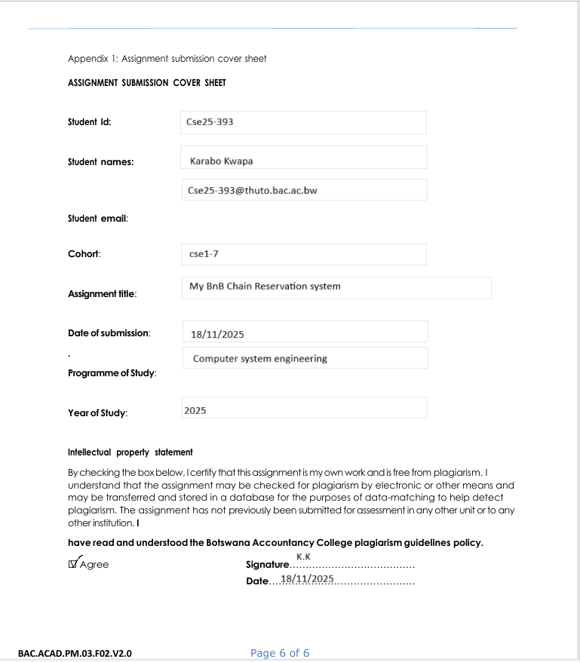
22/05/2026
2026
21/05/2026
WMD
Olympus
Garments

1.Website Specifications:
a) Website objective
Introduction
The goal of the Olympus website is to help diversify and provide a selection of different garments to enhance street culture aspect of fashion to issue scalability aiming for ecological and a circular economy on a global scale.
Goals of company
-The company will be able to promote Sustainable Ecommerce through use of website by targeting a global market.
-Engaging Community by involving the target audience in collection drops, voting on next designs and promoting collabs.
-Engaging brands to collaborate with Website to help promote local brands to create international exposure.
-Promoting local craftmanship through global trade.
-Increasing eco-friendly resource to appeal to eco-conscious youth (product care, recycle fabrics and eco-friendly packaging).
-Bridging digital and physical spaces by creating a seamless style expression across real and online space for easier access by the Youth.
b) Target audience
Engaging individuals, fashion enthusiast youth, models and eager creatives and artists diversifying their fashion lifestyle with agile and distinct apparel to equip them with garments that showcase individuality .
Demographic
Age
16-45
Gender
male/ female(Unisex)/other
Location
global scale(rural and urban areas with access to shopping centres )
Technical Aptitude
-Individuals with aptitude in online transactions and online business competency
-Can be able to navigate the website and give detailed research about product preference.
-Basic computer skills (Customers will be provided with links and sidebars to assist with information and tutorials to guide users).
2. Information Design & Taxonomy
Page 1
Introduction Page
Displays Brand title design and reveal the brand slogan to help customers get an aesthetic appeal and interest in the website.
It presents different navigation bars to guide the customer into other pages linked to the website e.g. The Collab section and the contact page.
Page 2
Home page(index.html)
-Illustrates the different Collection options (T-shirts, pants, shirts, hoodies and sweaters)
-Brand design and slogan
-Brand collabs
-Adding Navigation paths to; Body (Features Displayed)
-Displaying prices under the products, merchandise
Page 3
Contact Page
This page gives client to have access to contacting the company through different links and leaving reviews about product to give company feedback on products.
( Emails, survey, contact information and address)
Page 4
About Page
Customers get a sense of that the brand is about to help get a better feel of the product and the company vision. (product information, FAQ, Brand mission, brand identity)
Low level fidelity
This illustrates the design structure and how the navigation of the different navigation paths direct the user to have access to different options accessible through the website.
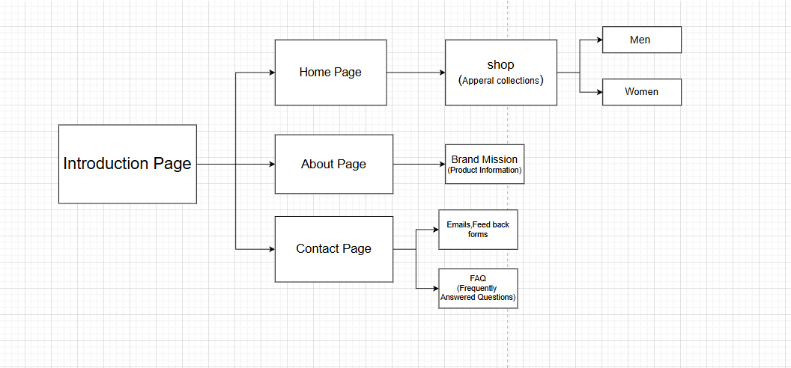

High level fidelity
This layout displays a demo webpage to aid in showcasing content and how the webpage will look like overall will look like.
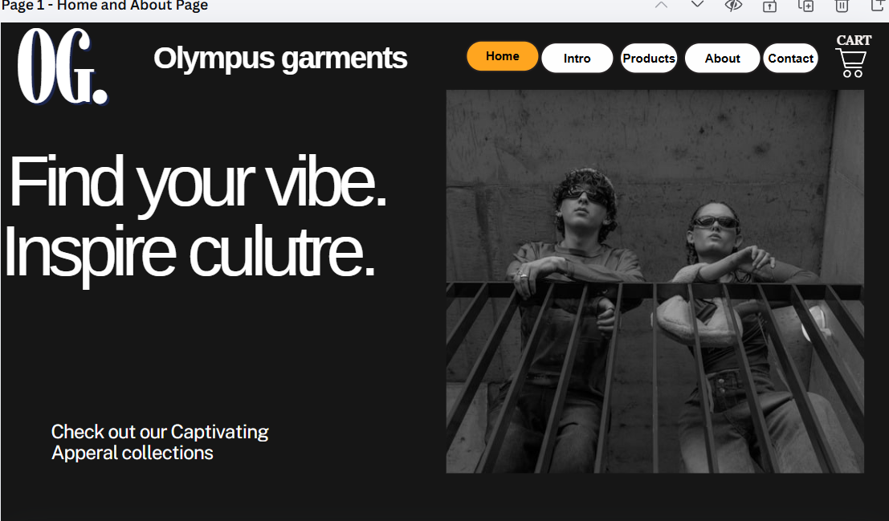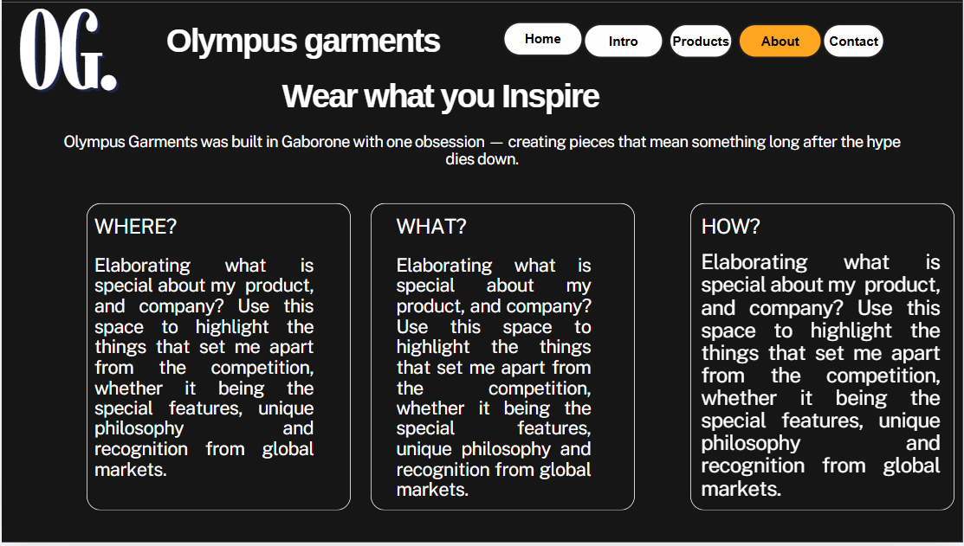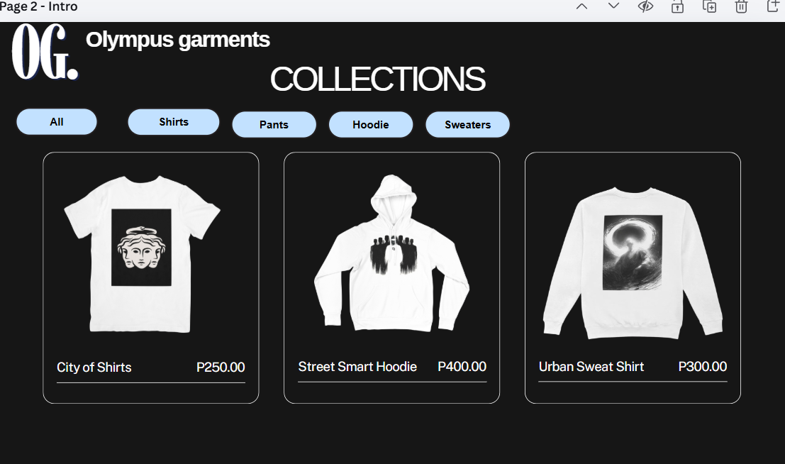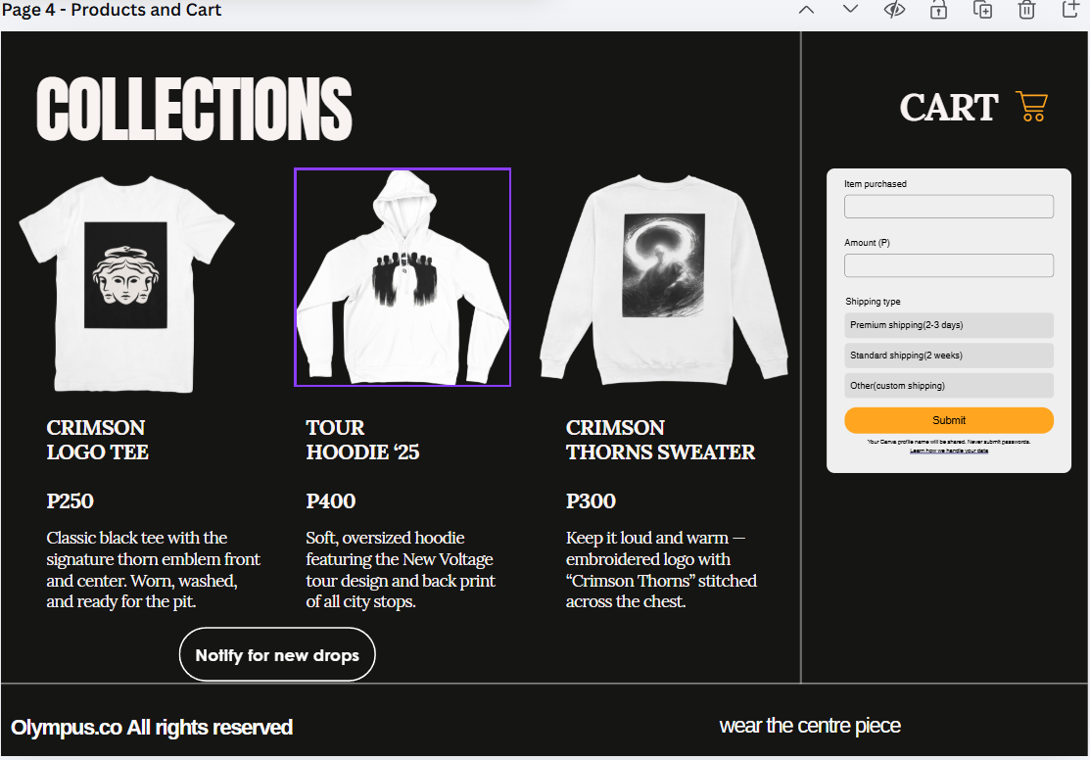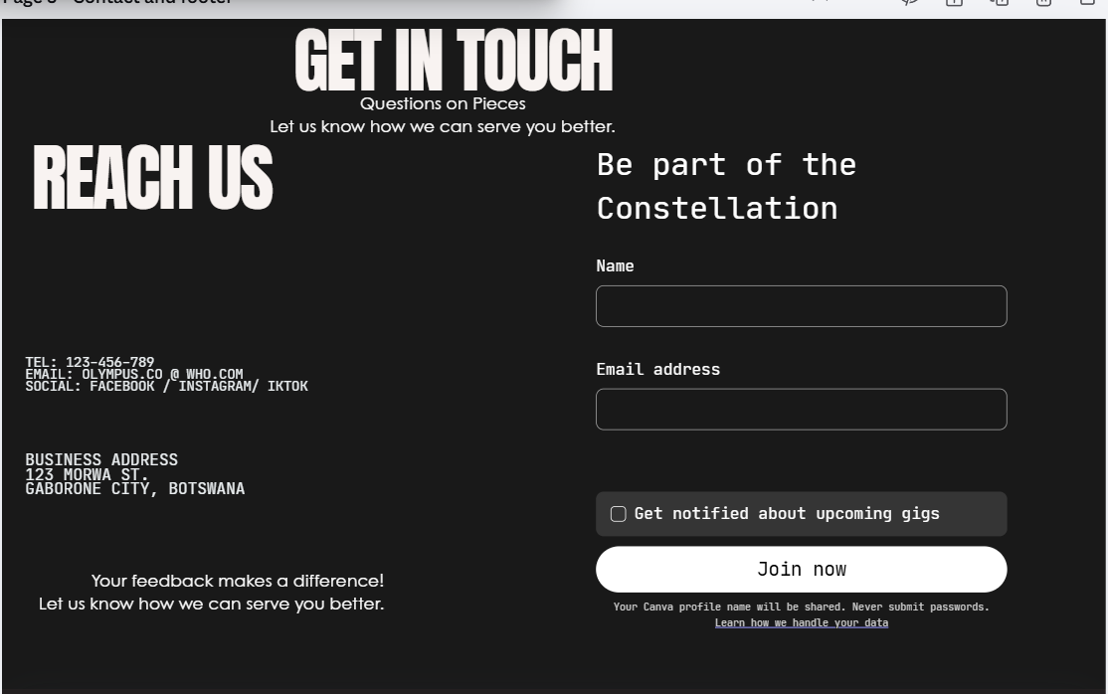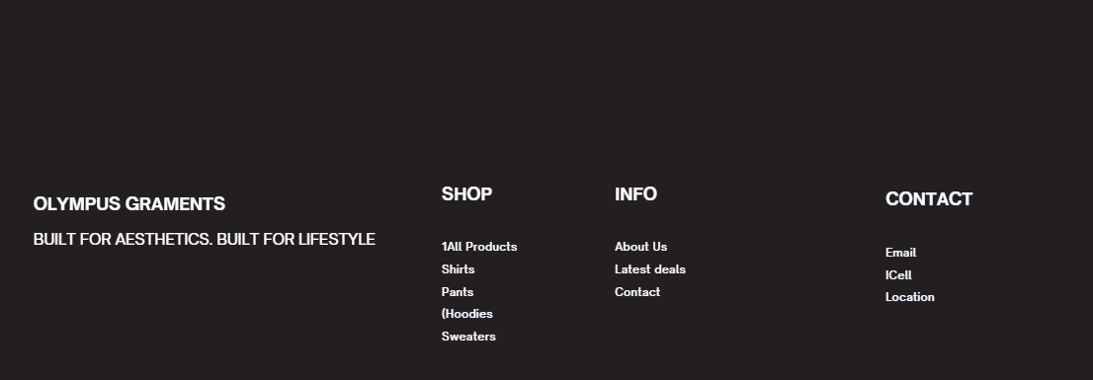

Technical Brief
GitHub
it is a cloud-based platform that aids in housing, maintaining and editing back-end code
Visual Studio
It is a programming software that allows code execution
Html (Using a fifth edition of the hypertext markup language that is used for back end code for the website design, it also aids to edit and publish the website platform
Canva/ Affinity
These are editing software that help designers create and illustrate projects
this will help me use it to create the high and low fidelity wire frames to help guide the project through the simple layout and display the final project
Pinterest
Used to get images for products

